**Practical.No.5**

**Aim: Define a JavaScript code for Performing various Mathematical Operations such as:**

1.Calculating Factorial

2.Displaying Prime Numbers

3.Finding Fibonacci Series

4.Addition of numbers

5.Evaluating Expressions using eval() function

6.Calculating Reverse of the number

**5.1 Calculating Factorial**

program:

<html>

<head>

<title>Calculating Factorial</title>

<script>

function display()

{

var i=1;

var fact=1;

var a=Number(document.getElementById("num").value);

for(i=1;i<=a;i++)

{

fact=fact*i;

}

document.write("Factorial of the given number is: "+fact);

}

</script>

</head>

<body>

<label>Enter number:</label>

<input id="num">

<input type="button" onclick="display()" value="Result">

</body>

</html>

**Output:**

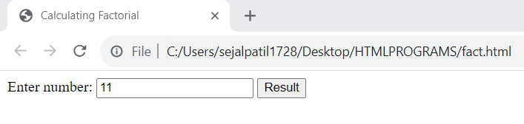

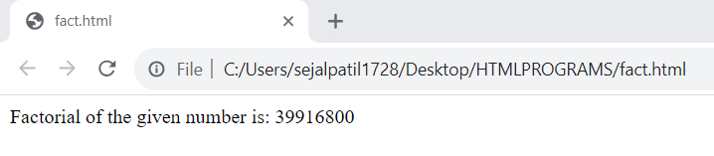

**5.2 Displaying Prime Numbers**

Program:

<html>

<head>

<script>

function prime()

{

var i;

var j;

var counter;

var num=Number(document.getElementById("num").value);

document.write("Prime number are:");

for(i=1;i<=num;i++)

{

counter=0;

for(j=1;j<=i;j++)

if(i%j==0)

{

counter++;

}

if(counter==2)

{

document.write("<br>"+i);

}

}

}

</script>

<body>

<h1>Calculating prime Number in JavaScript</h1>

<label>Enter Number:</label>

<input id="num">

<input type="button" onclick="prime()" value="PrimeNumber">

</body>

</head>

</html>

**Output:**

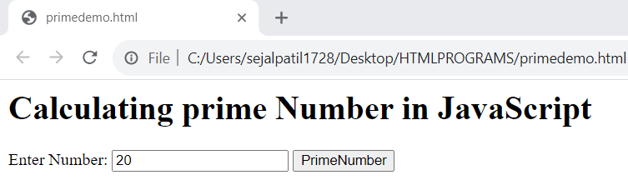

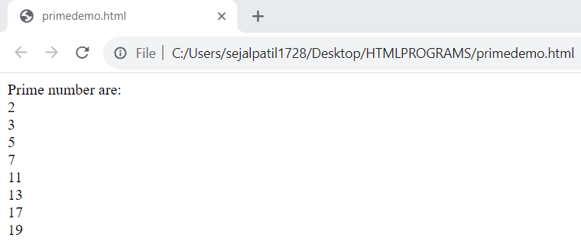

**5.3 Finding Fibonacci Series**

Program:

<!DOCTYPE html>

<html>

<head>

<title>Fibonacci Series</title>

<script>

function Fibonacci()

{

var a=1;

var b=0;

var c;

var num=Number(document.getElementById("num").value);

document.write("fibonacci series:");

for(a=1;a<=num;a++)

{

document.write("<br>"+a);

c=a+b;

a=b;

b=c;

}

}

</script>

</head>

<body>

<h1>Calculating FibonacciSeries in JavaScript</h1>

<label>Enter the number:</label>

<input id="num">

<input type="button" onclick="Fibonacci()" value="Fibonacci">

</body>

</html>

**Output:**

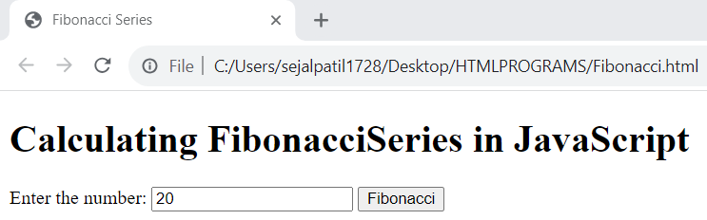

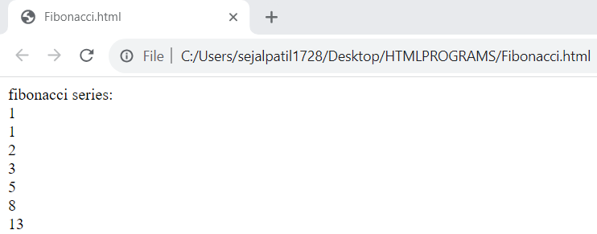

**5.4 Addition of numbers**

Program:

<!DOCTYPE html>

<html>

<head>

<script>

function addition()

{

var a=Number(document.getElementById("first").value);

var b=Number(document.getElementById("second").value);

var c=a+b;

document.write("Addtion of two number : "+c);

}

</script>

</head>

<body>

<h1>Addition of Two Number in JavaScript</h1>

<label><br>Enter first number:<br></label>

<input id="first">

<label><br>Enter second number:<br></label>

<input id="second">

<br>

<br>

<input type="button" onclick="addition()" value="Addtion">

</body>

</html>

**Output:**

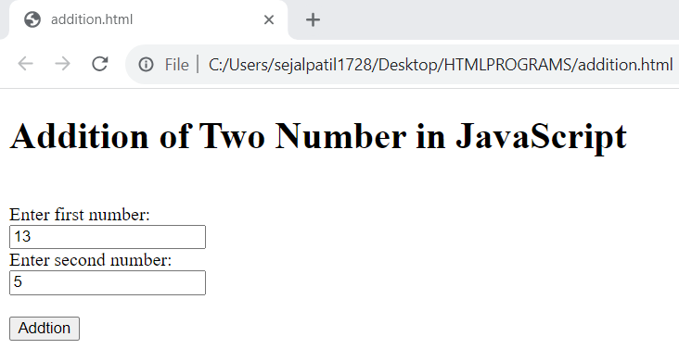

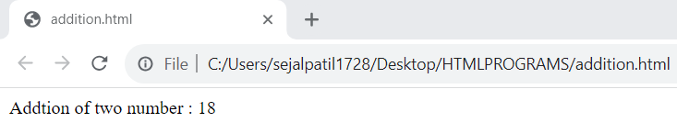

**5.5 Evaluating Expressions using eval() function**

Program:

<html>

<head>

<script>

function myFuntion()

{

document.write("Evaluting expression is:<br>");

var x=10;

var y=20;

var a=eval("x+y")+"<br>";

var b=eval("2+2")+"<br>";

var c=eval("x+17")+"<br>";

var res=a+b+c;

document.write(res)

}

</script>

<body>

<h2>click on button to evalute javascript code/expression</h2>

<input type="button" onclick="myFuntion()" value="Try it">

</body>

</head>

</html>

**Output:**

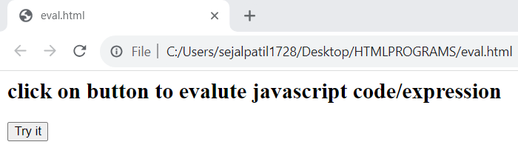

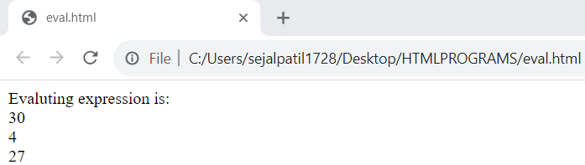

**5.6 Calculating Reverse of the number**

Program:

<!DOCTYPE html>

<html>

<head>

<title>Reverse number</title>

<script>

function reverse()

{

var a,num,temp=0;

num =Number(document.getElementById("num").value);

while(num>0)

{

a=num%10;

num=parseInt(num/10);

temp=temp*10+a;

}

alert(temp)

}

</script>

</head>

<body>

<label>Enter Number:</label>

<input id="num">

<input type="button" onclick="reverse()" value="Find_reverse_number">

</body>

</html>

**Output:**

